**Ex:** 11

**Date:** 20/11/2020

**Aim:**

To Write a Python program to find the greatest common divisor of two integers using recursion.

**Program:**

def gcd(a,b):

if(b==0):

return a

else:

return gcd(b,a%b)

a=int(input("Enter First Number:"))

b=int(input("Enter Second Number:"))

GCD=gcd(a,b)

print("GCD is: ")

print(GCD)

**Output:**

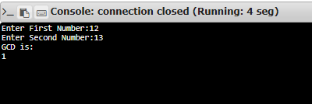

**Result:**

Thus, finding GCD of two numbers is done using recursion concept is done in python.

**Link:**

<http://103.53.53.18/mod/vpl/forms/submissionview.php?id=326&userid=1652>